**As we approach Christmas this year, there are some things that employers should be aware of to support them plan for the holiday period. This guidance provides an overview of the holiday shutdown, annual leave and JIB holiday pay rates and arrangements.**

**Key information**

**This guidance provides information on:**

* Christmas shutdown
* JIB Christmas holiday pay rates and arrangements
* JIB pay rates increase from **Monday 6 January 2025**
* JIB Lodging Allowance/ Mileage rate

**1. Christmas shutdown**

Traditionally, many employers have implemented a two-week shutdown over Christmas and New Year. This consisted of three bank/ public holidays (Christmas Day, Boxing Day, and New Years’ Day) and seven days of annual leave.

Given there is no longer a formal shutdown period for the industry, you may wish to note the dates for the Construction Industry Joint Council (CIJC) and BESA Winter Break which are the same and as follows: the last working day will be Friday 20th December 2024 and the first day back at work is Monday 6th January 2025.

You can of course develop your own arrangements.

**2. JIB pay rates**

Operatives employed under the JIB National Agreement are entitled to paid time off for the three days of public holiday at the Christmas/ New Year period (Christmas Day, Boxing Day, and New Year's Day).

A normal day’s pay, as defined by National Working Rule 13, at the appropriate JIB rates should be paid. Operatives must work full time for the normal day on the working days preceding and following the holiday to qualify for payment.

An operative will also qualify if they

* Lost time through certified sickness,
* Were on a rest period for the day following continuous working all the previous night.
* Were absent with the employer’s permission.

When operatives are required to work on a paid holiday they should receive

1. Christmas Day – double time and a day shift off in lieu which is mutually agreed and paid at normal rates.
2. Boxing Day and New Years Day – time and a half plus a day off in lieu which is mutually agreed and paid at normal rates OR 2 and a half time the rate.

**Call Out**

Operatives called out on a bank holiday should also receive time off equivalent to the period which they were called out home to home.

**3. JIB Pay Rates 2025**

A reminder that the pay rates for JIB graded operatives and apprentices increase by 5% on Monday 6 January 2025. The full list of rates can be found [here](https://www.jib.org.uk/handbook/national-working-rules/).

**3.1 JIB Lodging Allowance 2025**

The increased tax-free payments from 6 January 2025 are:

Lodging Allowance - £51.29 per night

Annual Holiday Retention payment - up to a maximum of £16.87 per night

(£118.09 per week)

Weekend retention - £51.29 per night

**4.2. Mileage Allowance**

Under the JIB Agreement, the tax-free Mileage Allowance remains 22p per mile.

**Further advice and assistance**

ECA Members with detailed queries not fully answered here are encouraged to contact the ECA Employee Relations Helpline:

* Email: [employeerelations@eca.co.uk](mailto:employeerelations@eca.co.uk?subject=Support%20Request)
* Tel: 0207 313 4800

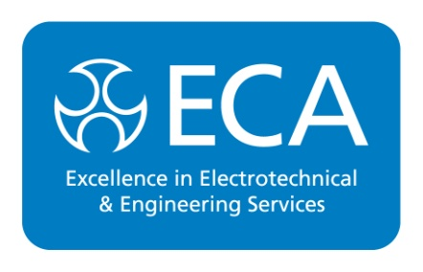

The ECA Logo is a Registered Collective Mark. Information presented is accurate at time of printing.

ECA, Rotherwick House, 3 Thomas More Street, St. Katharine’s & Wapping, London E1W 1YZ

**Tel**: 020 7313 4800 **Email**: [info@eca.co.uk](mailto:info@eca.co.uk) [**www.eca.co.uk**](http://www.eca.co.uk)

Rev: 0423